**Phase 1 project:**

**insta clone database**

# OVERVIEW

This is the database of fake social media. You are the data analyst of this company and you have to work with the marketing department in several marketing operations

**👉 Kindly click on the** [**file**](https://drive.google.com/drive/folders/1u_mw0j9NCLeR0fPjDFOdoVrVukofnXYH?usp=share_link) **to check and download**

Above link contains the .txt file which have create and insert sql code of the database. You have to co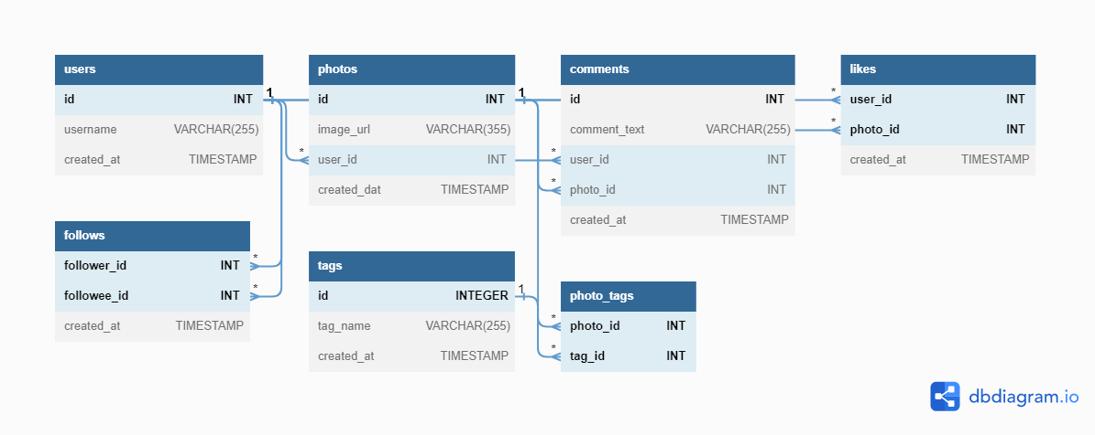py the code and paste it in a blank sql workbench sheet. Press ctrl+A then run the entire code by clicking on the left lightning symbol.

Below is the EER diagram of the database:

You can create your own EER diagram in MYSQL:

**Database tab > reverse Engineer… > Next > enter password > Next > chose database(ig_clone) > Next> Execute > Next > Finish**

The dataset provided to you contains 8 tables :

**users** - contains the information of users

**photos**- constraints the photos posted by users

**Follows**- user follow which user

**tags**- tags applied in photos

**Comments**- comments done by user

**Photos_tags**- user who are tagged

**Likes**- information about likes on photos

# GOALS

1. You have to work with the marketing team and retrieve the required data which are needed for the marketing campaign.

# Prerequisites

You have good understanding of Data Analysis, JOINS, CASE, Clauses & Operators

# Task Questions:

1. Find the 5 oldest users.
2. What day of the week do most users register on? We need to figure out when to schedule an ad campaign.
3. We want to target our inactive users with an email campaign.Find the users who have never posted a photo
4. We're running a new contest to see who can get the most likes on a single photo.WHO WON??!!
5. Our Investors want to know… How many times does the average user post?HINT - *total number of photos/total number of users*
6. user ranking by postings higher to lower
7. total numbers of users who have posted at least one time.
8. A brand wants to know which hashtags to use in a post

What are the top 5 most commonly used hashtags?

1. We have a small problem with bots on our site...Find users who have liked every single photo on the site.
2. Find users who have never commented on a photo.